The Harris Shop – Open Call
Retail Commission Opportunity:
Design products and souvenirs inspired by our collections and built heritage.

The Harris is looking for expressions of interest from artists, designers or creative enterprises. We’re seeking artists to engage with our collections and built heritage to design a range of quality products inspired by Preston and/or the Harris and its collections which will be sold in the Harris shop.

The Harris has a wealth of objects and artworks which we hope will inspire a range of contemporary and innovative designs. These products will be sold at a range of prices so that we have a good variety of items suitable for most pockets. The commissions can range from more ‘mass produced’ products to bespoke and limited edition items.

We will appoint a number of artists to develop their work into saleable products.
Commission value £750

Selection Process
Our priorities for selection are:
- Proposals from artists living and working in the North West region producing work of high quality. We will consider and work with artists from further afield, if they put forward interesting ideas and can demonstrate that their work is innovative and of high quality.
- You can address all the practical issues such as budget, insurance and that you have identified any risks and have strategies to reduce or remove them.
- You can estimate the quantity of products to be supplied in August. For example, you could propose 70 tea towels, 20 screen prints or 7 silver bangles.
- You must have a bank account, be registered as self-employed and be able to provide a UTR (Unique Tax Reference) number.

Recording the process
We want to create a blog or social media record to be created to show the development and progress of the work and to use as an engagement tool. This will be managed by the Harris, but input from artists will be required.

Resources Available
The Harris has a large range of resources including:
- An impressive variety of historic, art and costume collections and the built heritage of the grade I listed building.
In light of the current coronavirus situation, please see our virtual tours, we can also send photographs of specific items/areas on request.
- Support from Harris staff

Timescales

Deadline for applications | 5pm Friday 5 June 2020
Successful applicants notified | 5pm Friday 12 June 2020
Product development and research | Friday 12 June 2020 -  Friday 7 August 2020
Product manufactured and delivered by | Friday 7 August 2020
Product launch event | Wednesday 9 September

Budget and Payment Schedule
There is a fee of £750 per artist attached to this project which will cover your time for all activity, development work, production, attendance at launch event and other expenses. The fee will be paid in two installments:
- 80% – June 2020
- 20% – On receipt of products (early August 2020)

In your proposal we ask that you work out an estimated budget to include materials you will require in addition to estimated manufacturing costs per unit.

Please state whether the manufacturing will be outsourced and if this the case, whether you have worked with the manufacturer before. Alternatively, please state if you will need support in sourcing a suitable supplier or if you will produce the items yourself.

Application
Please include the following when sending us your expression of interest proposal:

- An outline of your ideas
- A budget outline of costs: manufacture, materials, artist research and design fee etc.
- Details of materials/resources you will be using
- Details of any specific technical requirements/specifications
- Links to websites containing examples of your previous work
- Your CV

If you would find it helpful, applicants are welcome to visit the Harris. If you would have any queries on accessing the building or the collections, please contact us on:
T: 01772 905414
E: theharris@preston.gov.uk

Please send your expression of interest, by no later than 5pm on Friday 12 June 2020 to:
theharris@preston.gov.uk

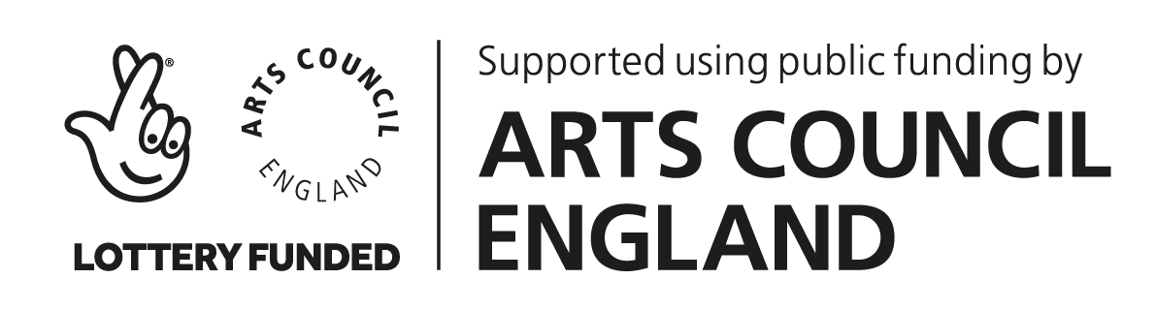

This commission is supported by the National Lottery though Arts Council England and managed by The Harris.

